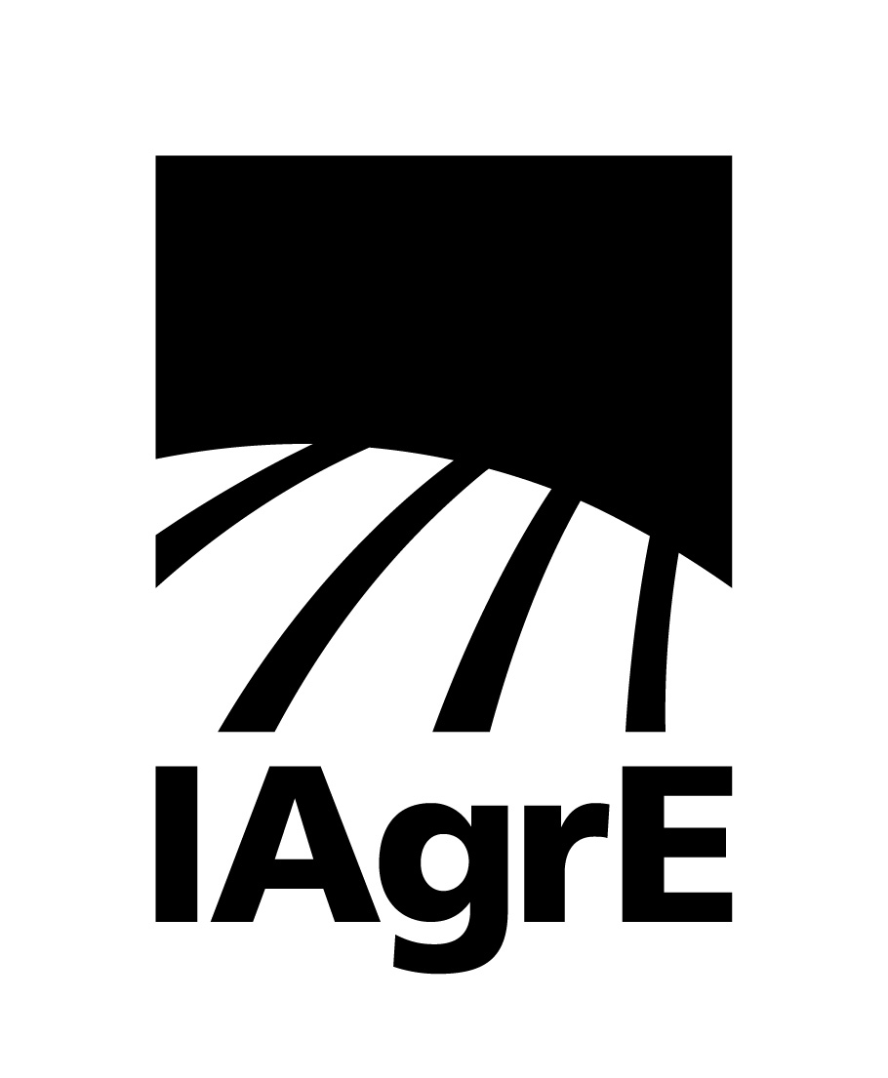

News Release

4 May 2023 Ref: 229

Two well know agricultural entrepreneurs receive honours from the Institution of Agricultural Engineers (IAgrE)

Andrew Newbold, a former President of IAgrE and the director of Newmac Ltd and Farm Smart Publishing and Events becomes an Honorary Fellow of the Institution and Ben Taylor-Davies(Regen Ben) a pioneer in the ‘regen ag’ movement is recognised for his Contribution to the Land-Based Sector at the IAgrE’s annual award ceremony.

“Andy is the ‘go to’ person at IAgrE. The combination of his engaging personality, experience of organising a wide range of events, knowledge of our subject area, and the people involved in our business means that he is uniquely placed to make an enormous contribution to the work of the Institution. A contribution both within and outside the Institution that fully justifies the highest award we can make of Honorary Fellow,” said Charlie Nicklin CEO of IAgrE.

Andy, a graduate of Harper Adams University, started Newmac Ltd in response to the implementation of the European Machinery Directive helping manufacturers and importers get to grips with product standards and CE marking.

Andy co-developed and launched Pro Operator as the membership publication for the National Register of Sprayer Operators (NRoSO) and this led to the formation of Farm Smart Publishing. He now edits and publishes Tillage and Soils, Precise and Agrimachinery Trade magazines. Alongside this he runs the National Sprayer Demo and is the event manager for Tillage-Live and ScotGrass.

On receiving his Fellowship from IAgrE President Steve Constable Andy said: “I’m humbled to receive this award. With a lifelong passion for Agricultural Engineering and engineers, I have always wanted tohelp in any way I can. I am incredibly fortunate to have been surrounded by positive role models and received their support throughout my career, which in turn has inspired me to help others.”

Describing himself as a ‘bioagriecologist’, Ben Taylor-Davies began to understand the benefits of integrating the environment with farming under the Countryside Stewardship Scheme, by planting new farm hedges and creating 6 metre margins for grey partridge and brown hares.

“Ben is an exemplar in practicing what he preaches on his family farm in Ross on Wye. He carries out on-farm trials to demonstrate to others that new ideas and concepts can be easily adapted and implemented on-farm for achieving results. He has amassed a large data base of regenerative and diverse farming practices and their outcomes for different soils and climates.

His enthusiasm is infectious wherever he speaks, and the Institution wish to recognise how Ben promotes more sustainable farming practices based on both scientific principles and practical experience,” said Mr Nicklin.

On receiving the award from IAgrE President Steve Constable Ben said: “It is an absolute honour and I am thrilled to receive this award. Thank you so much for recognising the work I am trying to do in the regenerative sector.”

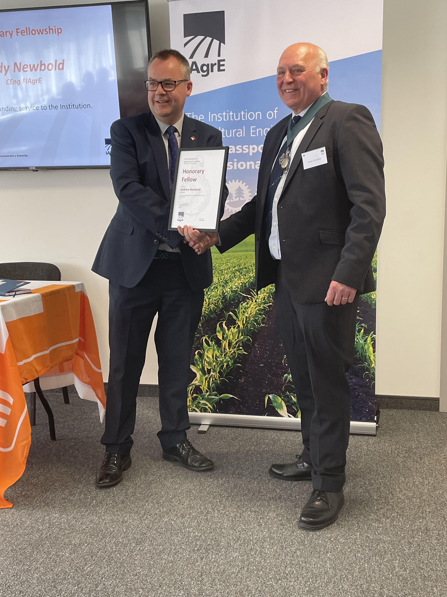

http://iagre.org/upload/1683198911.jpg

IAgrE:

IAgrE is the professional body for scientists, technologists, engineers, academics, managers and students working in the land-based sector and has an international membership base.

As a licensed body of the Engineering Council (EngC) and a founding Constituent Body of The Society for the Environment (SocEnv), IAgrE registers suitably experienced professionals as Chartered Engineer (CEng), Chartered Environmentalist (CEnv), Incorporated Engineer (IEng), Registered Environmental Practitioner (REnvP) and Engineering Technician (Eng Tech).

For further details, contact Marion King at communications@iagre.org or call 01234 750876 – mobile 07843382362

